Homework 8

Kathryn Atherton

ABE 58000

April 12, 2019

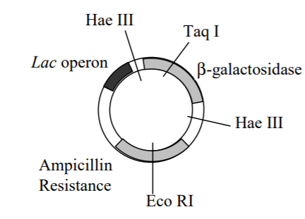

Schematic of plasmid with labeled genes (gray and black) and restriction enzyme cleavage sites.

# Problem 1

A gene for a promising biologic therapeutic (protein) is to be inserted into the plasmid above. What restriction enzyme(s) should be used to cleave the DNA and why?

**The Hae III restriction enzyme should be used as it is the only restriction enzyme that does not cut in the middle of a necessary gene. Once the DNA is cleaved, the new protein will be inserted either between the *Lac* operon and the β-galactosidase gene or between the β-galactosidase gene and the Ampicillin Resistance gene. The sticky ends of the cleavage site that does not take up the new protein will reattach to each other.**

# Problem 2

Edman degradation of a fragment from the desired protein gives a partial primary sequence of:

(N term) Tyr – Trp – Asp (C term)

What are the possible mRNA sequences that correspond to these amino acids? Please label the 5’ and 3’ ends of the oligonucleotides.

**Tyrosine has the possible mRNA sequences of UAC and UAU, Aspartic acid has the possible mRNA sequences of GAC and GAU, and Tryptophan only has the mRNA sequence of UGG. As such, there are four possible mRNA sequences corresponding to this sequence of amino acids (2 x 1 x 2), listed below:**

1. **3’ UAC – UGG – GAC 5’**
2. **3’ UAU – UGG – GAC 5’**
3. **3’ UAC – UGG – GAU 5’**
4. **3; UAU – UGG – GAU 5’**